“Buddy,” The Beagle, Tasting Notes

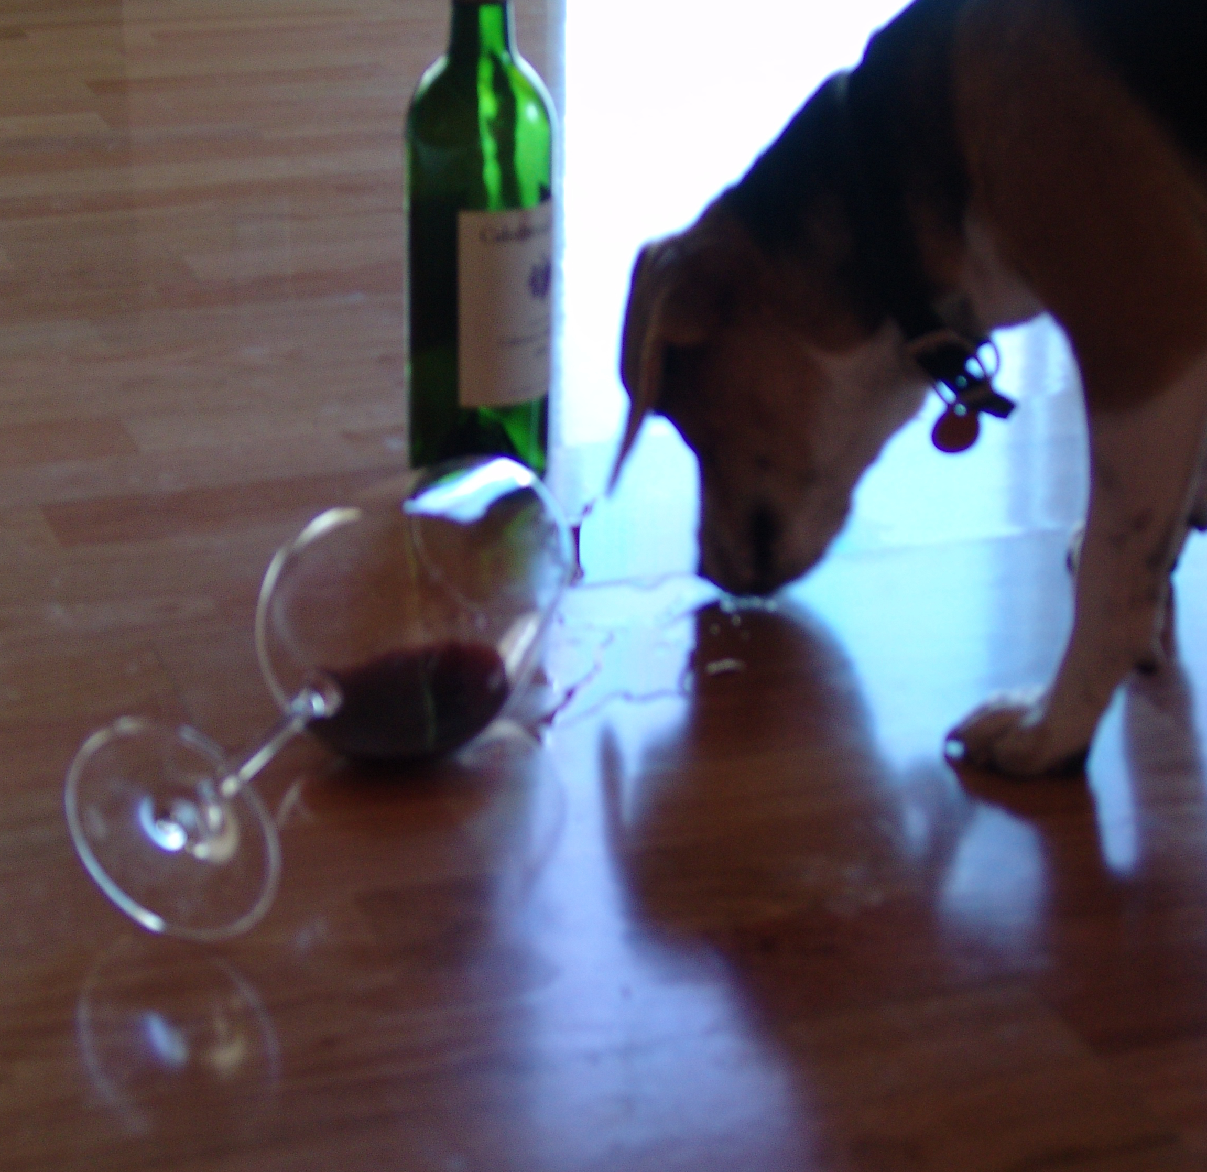

A glass of 2001 Cabernet Sauvignon from Napa Valley’s Cakebread Cellers:

Rich and full bodied like the poodle next door, with long legs to match.

Floral notes like the neighbors gardens with a whiff of oak that reminds me of my favorite tree to mark.

There are hints of wet socks and fine leather shoes like Jimmy Choos.

A long finish on the pallet with an aromatic burst of toilet water that rivals the greatest French bidets.

Recommended pairings are Alpo Filet Mignon or for a lighter fair, I recommend your favorite dry dog biscuit.

4 out of 4 fire hydrants

